#13 Name___________________________________ Period_______
Describe the transformation, then graph the following quadratics.
$$d\left(x\right)={(x-4)}^{2}$$  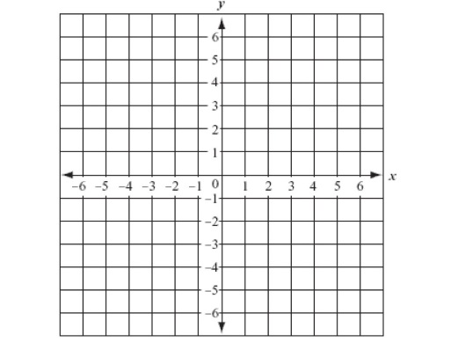 | g(x)=${(x+3)}^{2}$+2 | h(x)=${(x+1)}^{2}-3$
f(x)=${2x}^{2}$ | c(x)=$\frac{1}{2}x^{2}$ | d(x)=$-{\left(x-3\right)}^{2}+1$
Write the equation of the quadratic if the parent function is vertically stretched by a factor of 2 and translated 3 units to the right.
Write the equation of the quadratic if the parent function is reflected across the x-axis and translated six units down.
Describe each transformation of the quadratic parent function.
f(x)=$-{(x-4)}^{2}$ | f(x)=$8{(x+2)}^{2}$
f(x)=$4x^{2}$ | f(x)=${(x-4)}^{2}+3$

