SCORE _____________

*Combo Logs Review*

**Part I Write the letter for the correct answer in the blank at the right of each question*.***

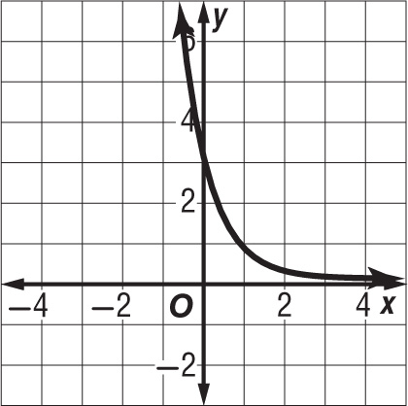 **1.** Find the domain and range of the function shown.

**A** D = {*x* | *x* > 0}, R = {all real numbers}

**B** D = {all real numbers}, R = {*y* | *y* < 0}

**C** D = {all real numbers}, R = {*y* | *y* > 0}

**D** D = {*x* | *x* > 0}, R = {*y* | *y* > 0}

**2.** Solve $4^{2x}$ = $8^{x + 4}$.

**F** 2 **G** 6 **H** 12 **J** 24

**3.** Write the equation $4^{3}$ = 64 in logarithmic form.

**A $\log_{3}{4}$**  = 64 **C $\log_{64}{3}$**  = 4

**B $\log_{4}{64}$**  = 3 **D $\log_{4}{3}$**  = 64

**4.** Evaluate $\log_{4}{32}$.

**F $\frac{5}{2}$**  **G** 8 **H** 3 **J $\frac{2}{5}$**

**5.** Solve $\log_{3}\left(7x-3\right)$ = $\log_{3}\left(5x\right)$.

**A $\left\{ x= \frac{3}{2}\right\}$**  **B $\left\{ x= \frac{3}{7}\right\}$**  **C** { *x* = 0} **D $\left\{ x= \frac{2}{3}\right\}$**

**6.** Write the equation $5^{4}$ = 625 in logarithmic form.

**F $\log_{4}{625}$**  = 5 **H $\log_{5}{625}$**  = 4

**G $\log_{4}{5}$**  = 625 **J $\log_{5}{4}$**  = 625

**7.** Write the equation $\log_{7}{49}$ = 2 in exponential form.

**A $7^{2}$**  = 49 **C ${49}^{2}$**  = 7

**B ${49}^{7}$**  = 2 **D $2^{7}$**  = 49

**8.** Write $\log_{\frac{1}{5}}{m}$ = –2 in exponential form.

9. Graph:  10. Graph: 





**1. ________________**

**2. ________________**

**3. ________________**

**4. ________________**

**5. ________________**

**6. ________________**

**7. ________________**

**8. ________________**

**9. ________________**

**10. ________________**